ReactJS HOL

Name: NALLANI LOKAKALYAN
Registered Mail: 2300030853cseh1@gmail.com

ReactJS HOL-1
Create a new React Application with the name “myfirstreact”, Run the application to print “welcome to the first session of React” as heading of that page.
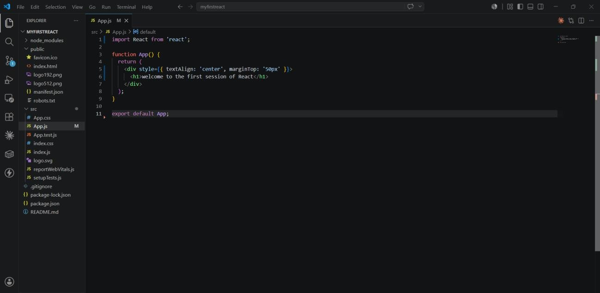
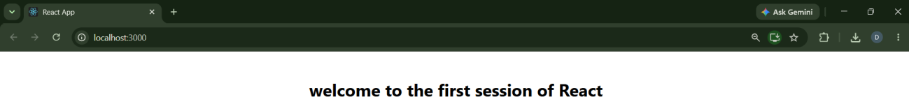

ReactJS HOL-2

Create a react app for Student Management Portal named StudentApp and create a component named Home which will display the Message “Welcome to the Home page of Student Management Portal”. Create another component named About and display the Message “Welcome to the About page of the Student Management Portal”. Create a third component named Contact and display the Message “Welcome to the Contact page of the Student Management Portal”. Call all the three components.
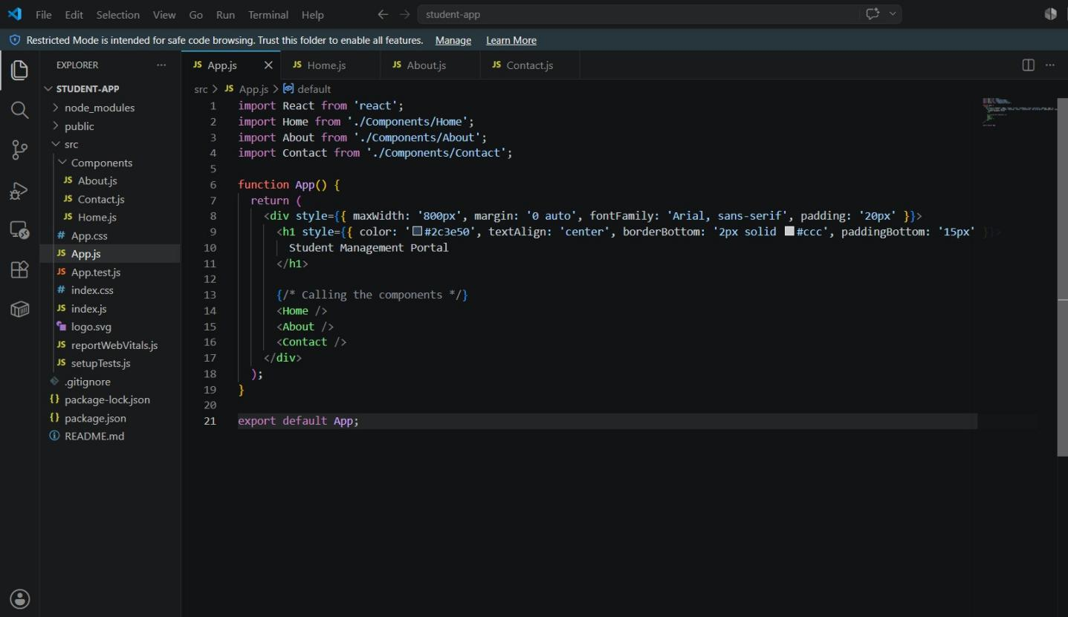
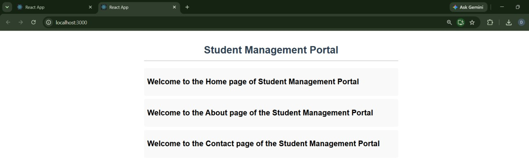

ReactJS HOL-3
Create a react app for Student Management Portal named scorecalculatorapp and create a function component named “CalculateScore” which will accept Name, School, Total and goal in order to calculate the average score of a student and display the same.

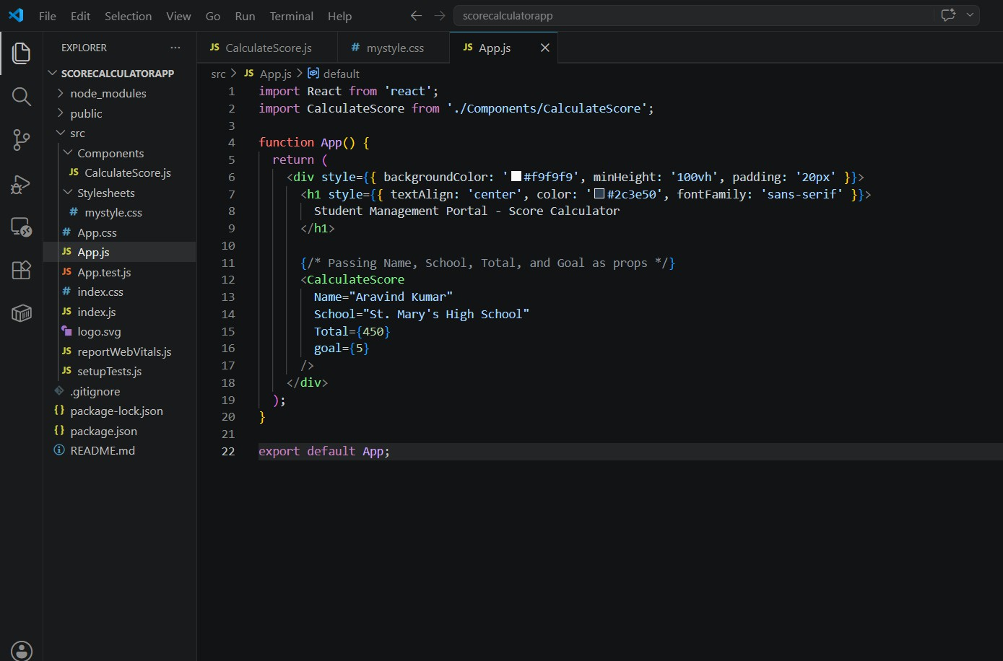
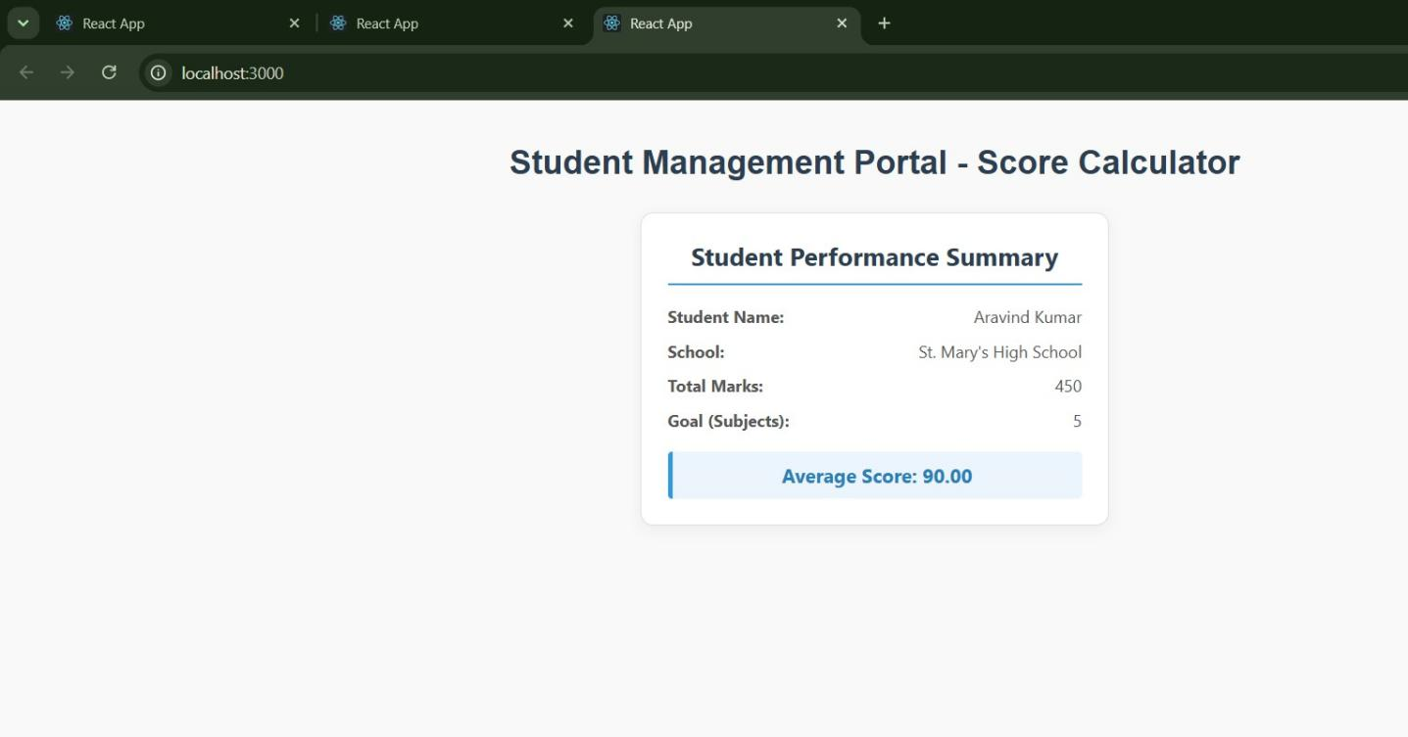

ReactJS HOL –4
1. Create a new react application using create-react-app tool with the name as “blogapp”

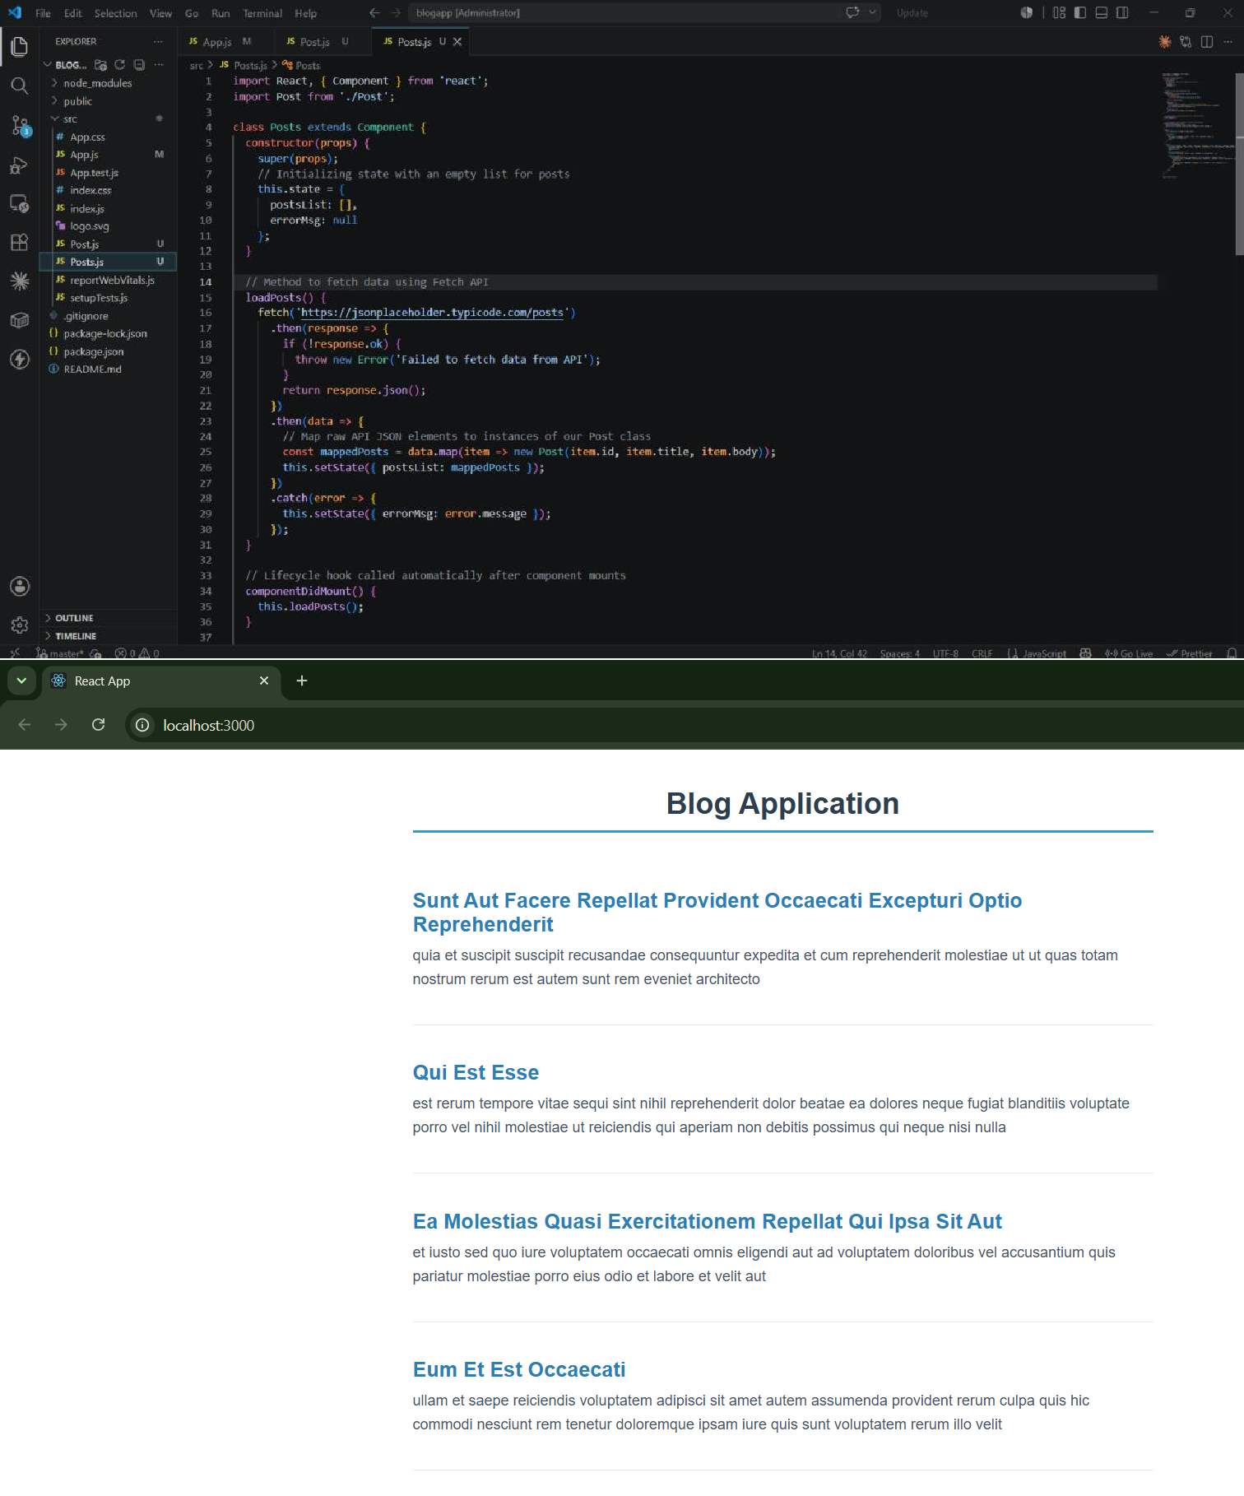

ReactJS HOL –5

Cognizant Academy teams want to maintain a list of trainers along with their expertise in a SPA using React as the technology. You are assigned the task of creating this React app.

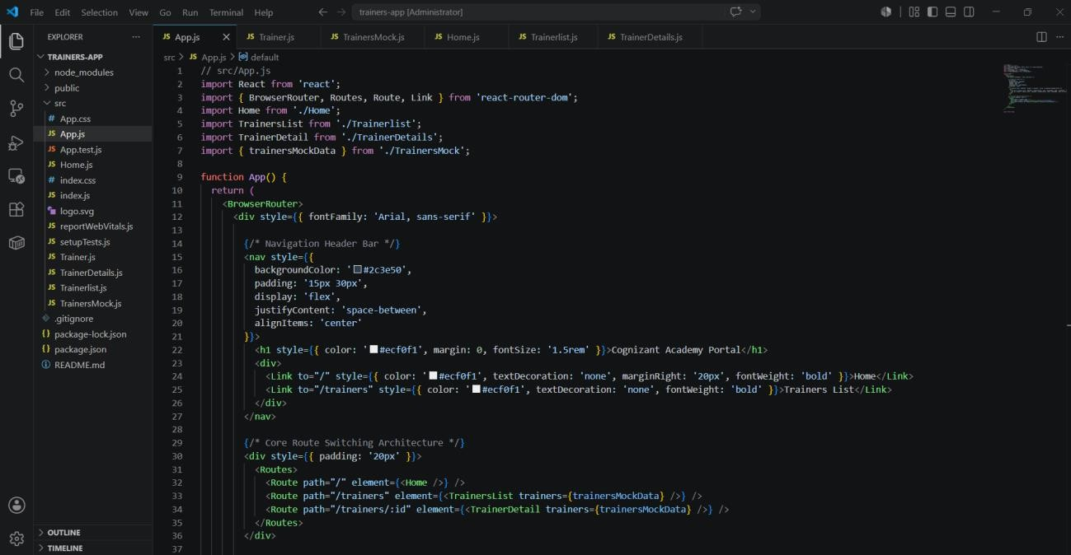
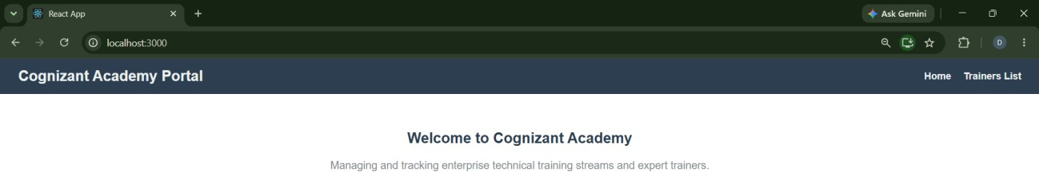

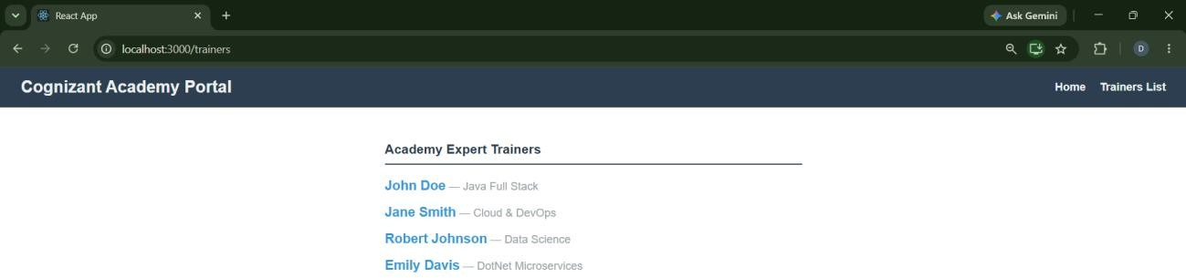

ReactJS HOL-6

Create a React Application named “shoppingapp” with a class component named “OnlineShopping” and “Cart”.
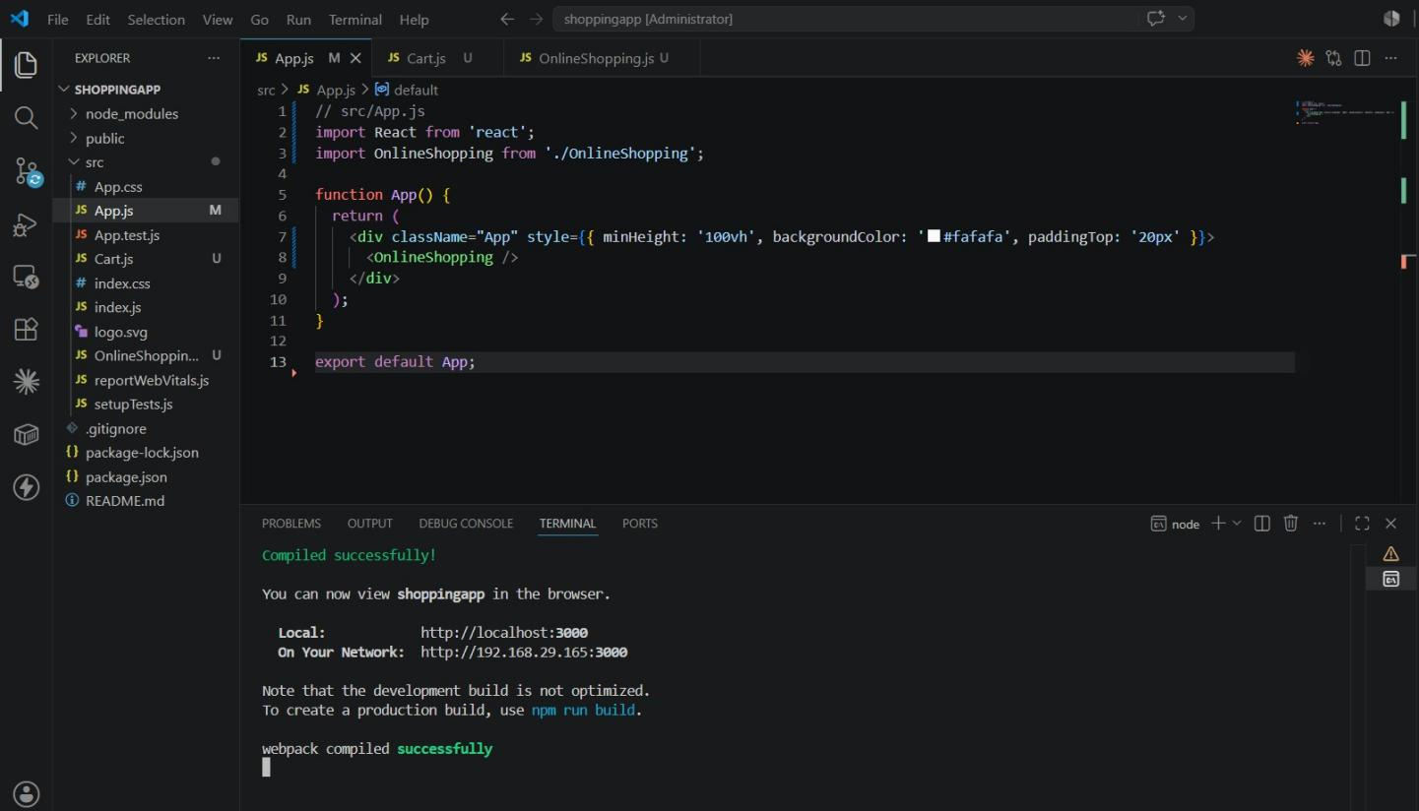
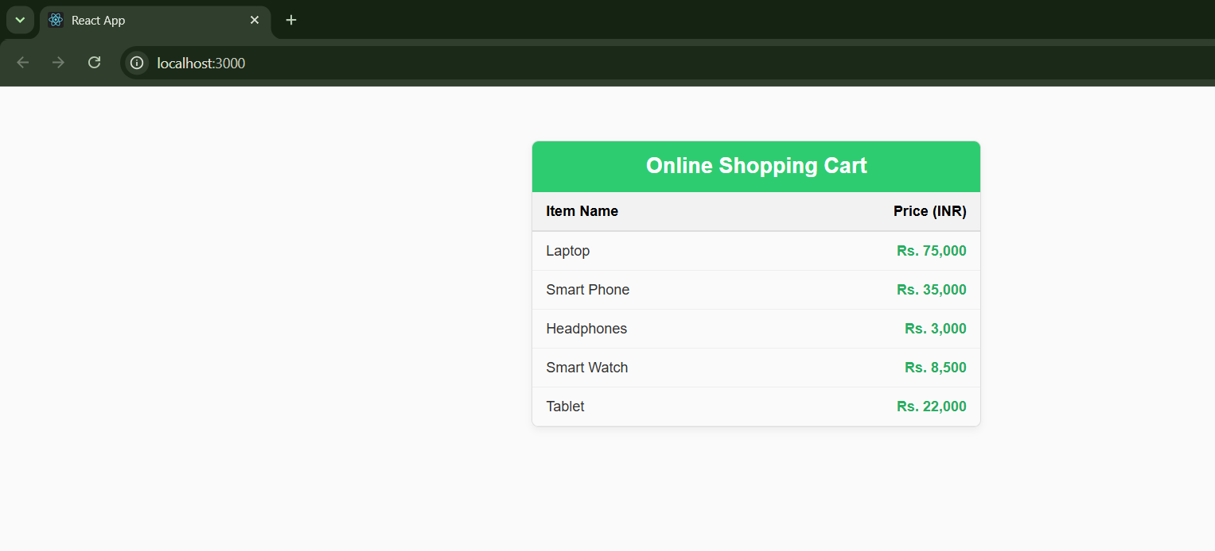

ReactJS HOL –7
Create a React App “counterapp” which will have a component named “CountPeople” which will have 2 methods.
UpdateEntry() → which will display the number of people who entered the mall.

UpdateExit() → which will display the number of people who exited the mall.
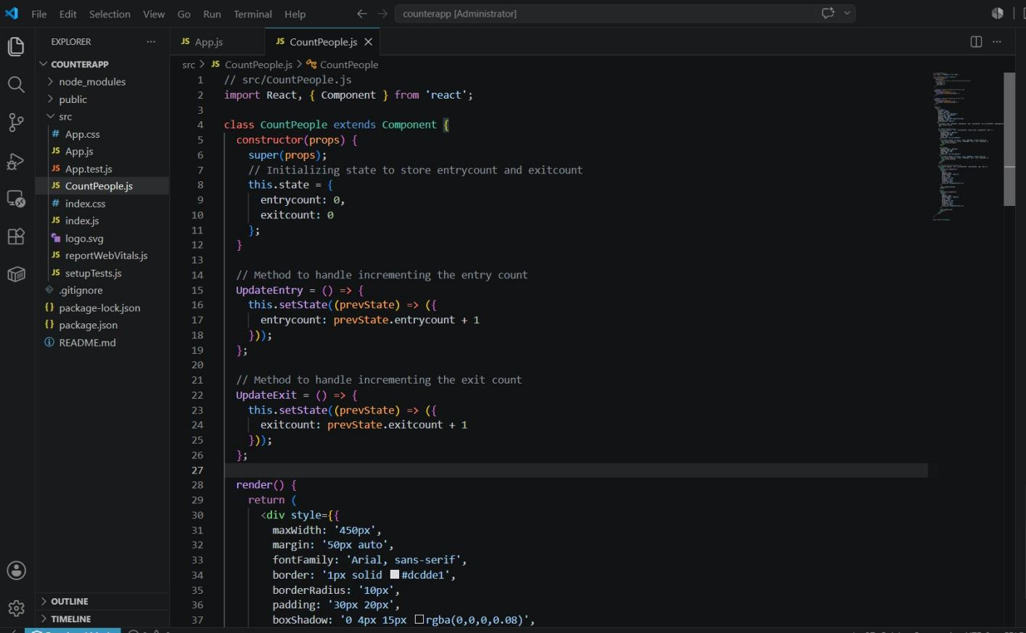
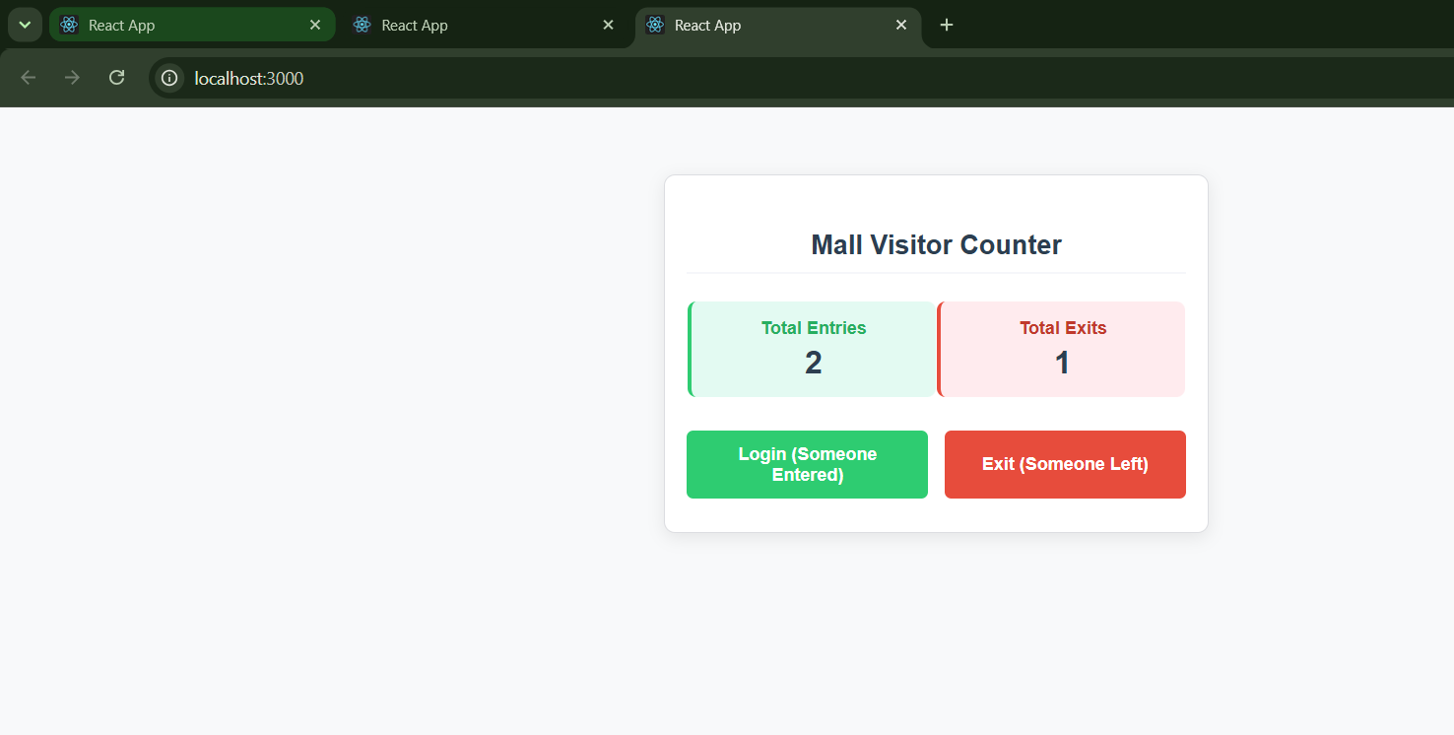

ReactJS HOL –8
Create a React Application named “cricketapp” with the following components:

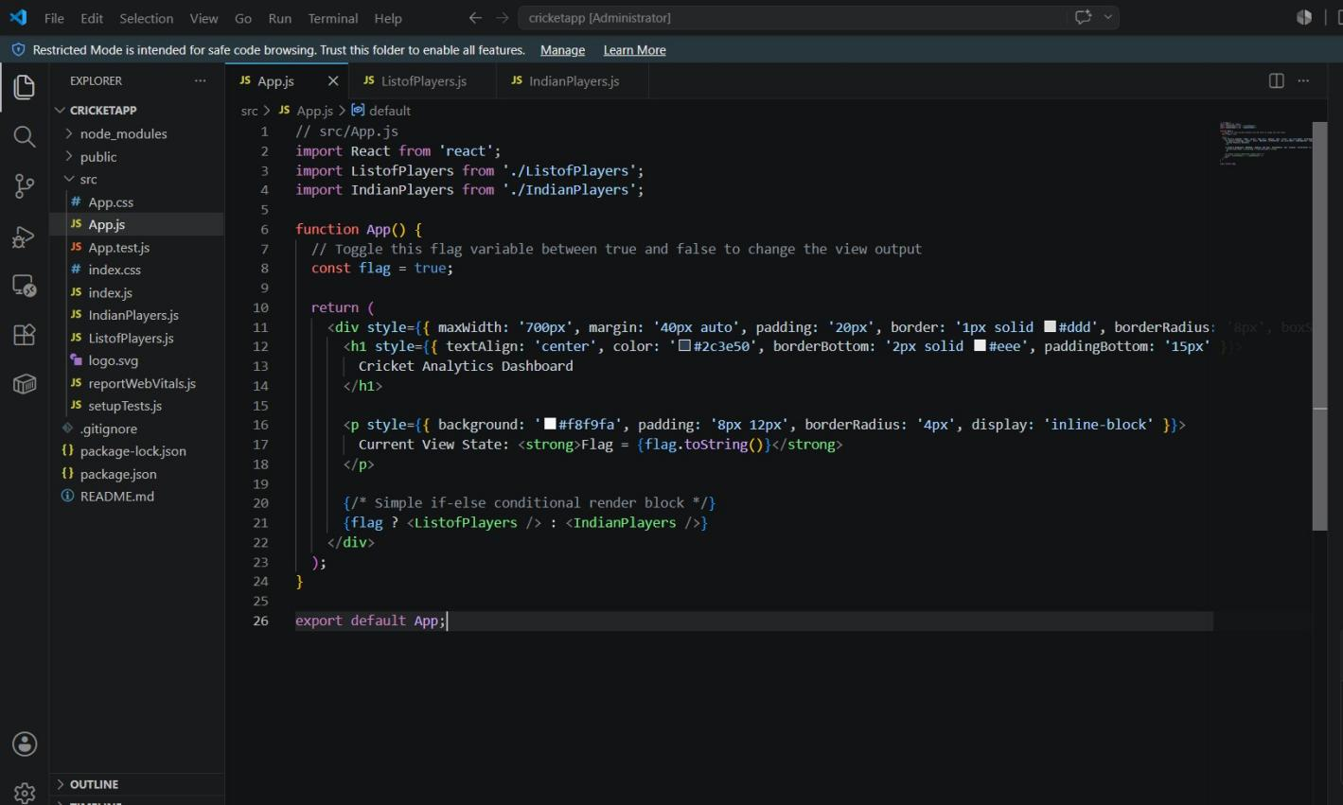
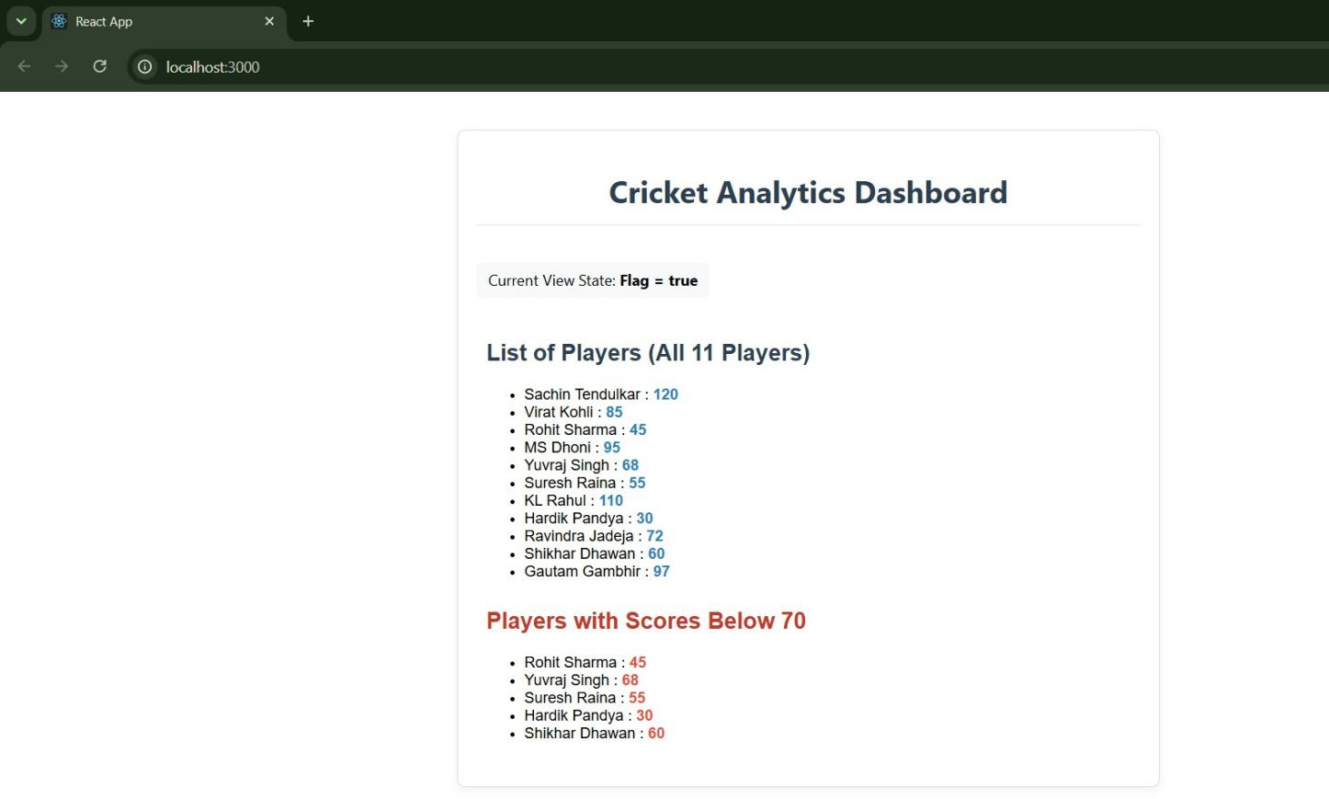

ReactJS HOL –9

Create a React Application named “officespacerentalapp” which uses React JSX to create elements, attributes and renders DOM to display the page.
Create an element to display the heading of the page. Attribute to display the image of the office space
Create an object of office to display the details like Name, Rent and Address. Create a list of Object and loop through the office space item to display more data.
To apply Css, Display the color of the Rent in Red if it’s below 60000 and in Green if it’s above 60000.
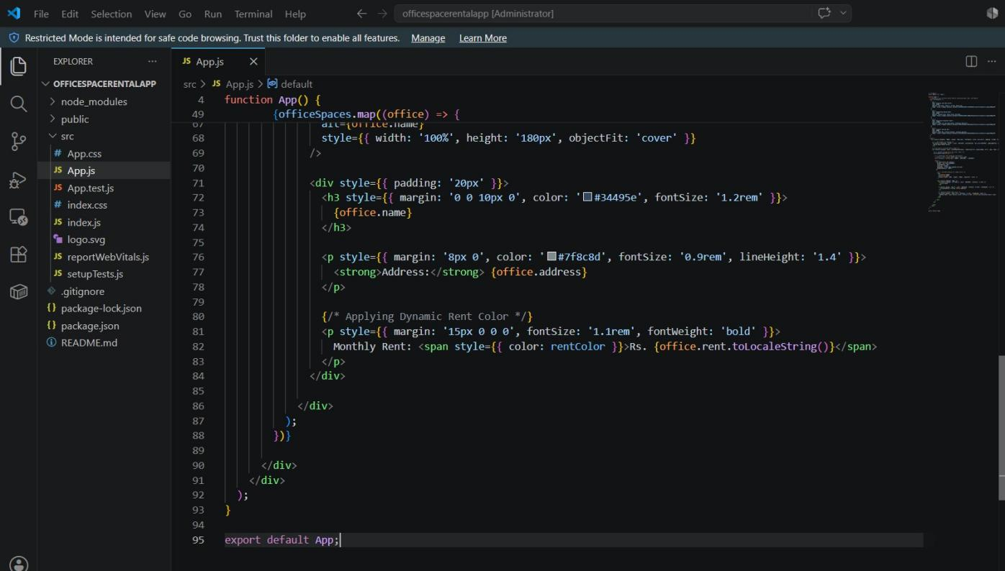

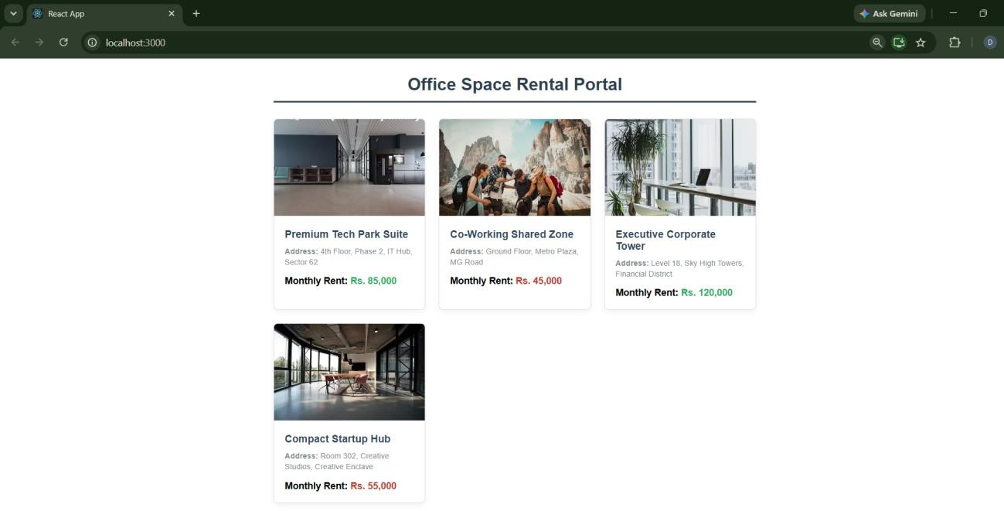

ReactJS HOL – 10
Create a React Application “eventexamplesapp” to handle various events of the form elements in HTML.

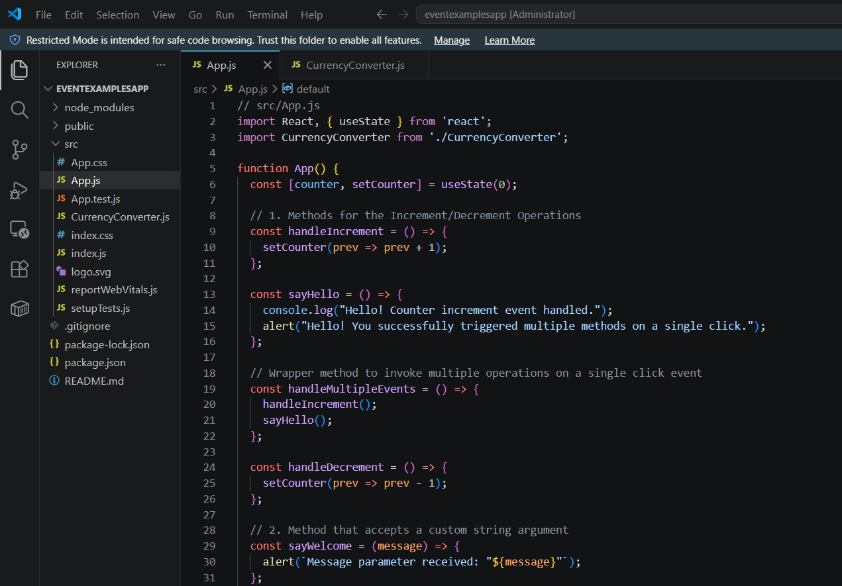

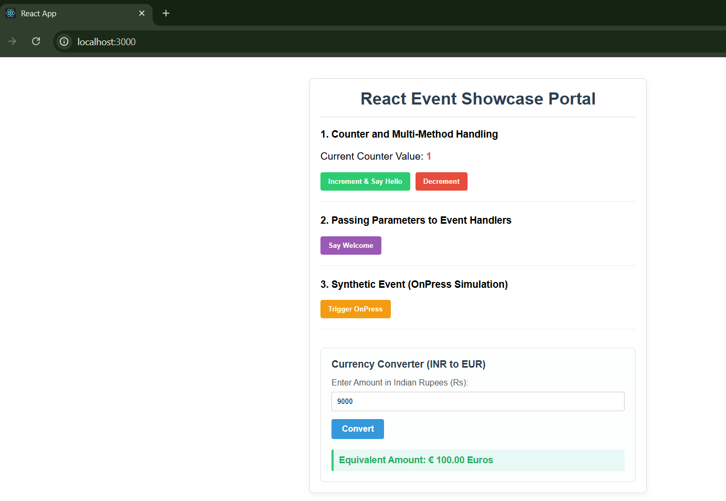

ReactJS HOL – 11
Create a React Application named “ticketbookingapp” where the guest user can browse the page where the flight details are displayed whereas the logged in user only can book tickets.
The Login and Logout buttons should accordingly display different pages. Once the user is logged in the User page should be displayed. When the user clicks on Logout, the Guest page should be displayed.

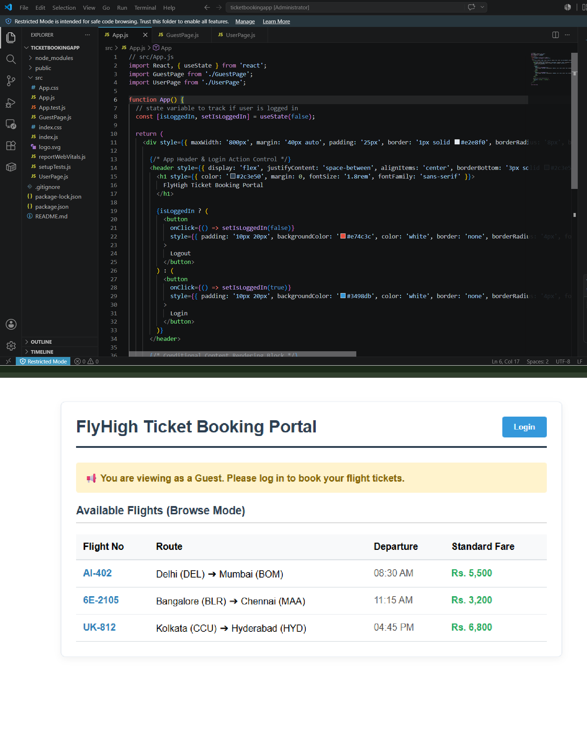

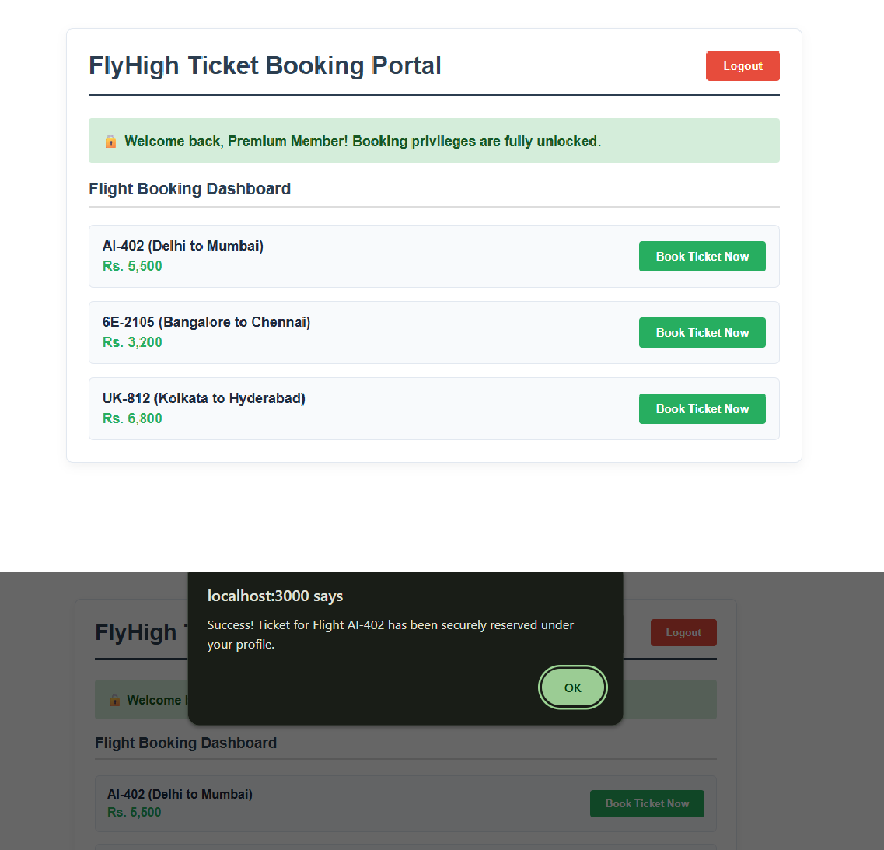

ReactJS HOL - 12

Create a React App named “bloggerapp” in with 3 components.

- Book Details
- Blog Details
- Course Details

Implement this with as many ways possible of Conditional Rendering.

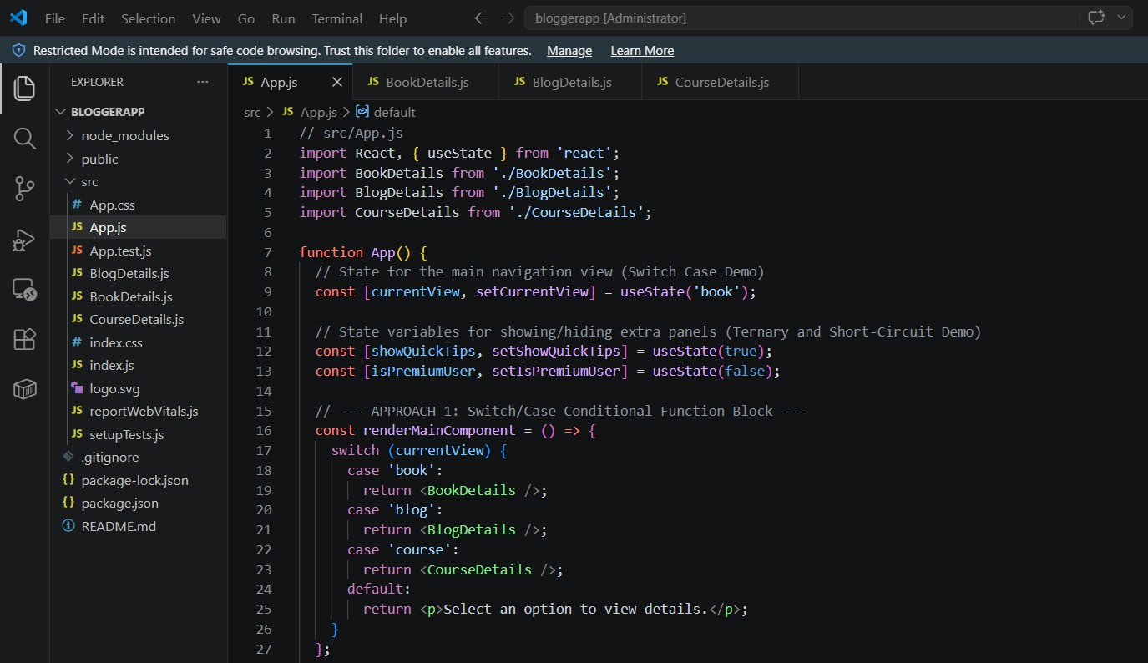





ReactJS HOL - 13
Create a React App named “ticketraisingapp” which will help to raise a complaint and get it resolved.

Create a component named “ComplaintRegister” with a form containing a textbox to enter the employee name and a textarea to enter the complaint. Use “handleSubmit” event of the button to submit the complaint and generate a Reference number for further follow ups in the alert box.

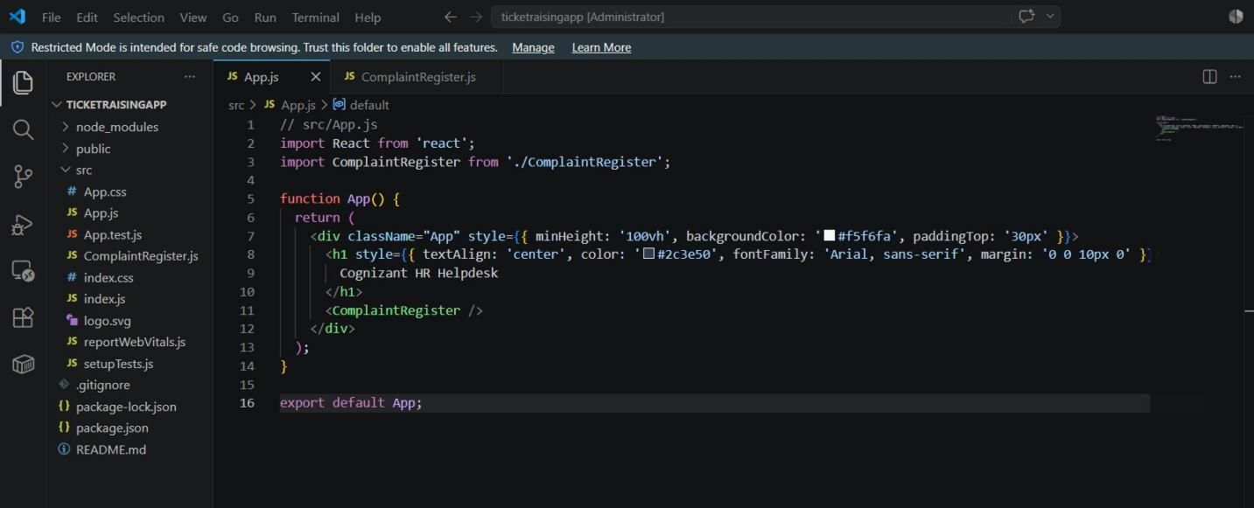
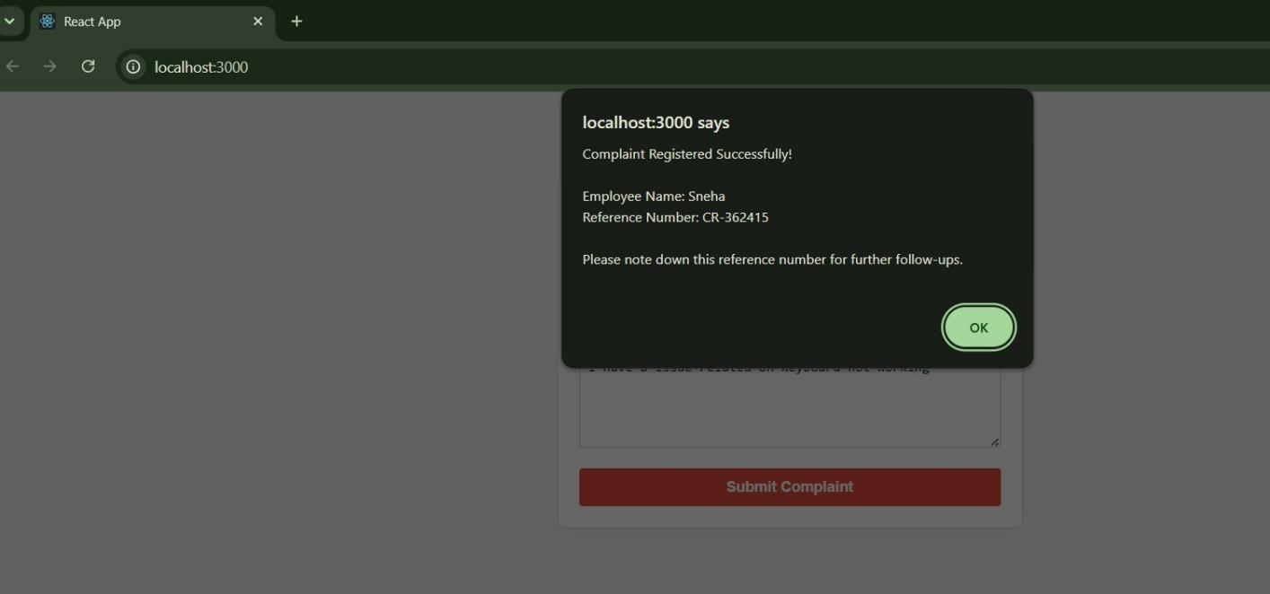

ReactJS HOL – 14
Create a React App named “mailregisterapp” which will have a component named “register.js”. Create a form which accepts the name, email and password and validate the fields as per the following:

- Name should have atleast 5 characters
- Email should have @ and .
- Password should have atleast 8 characters.

Ensure that validations are implemented through eventhandle and eventsubmit of a form.

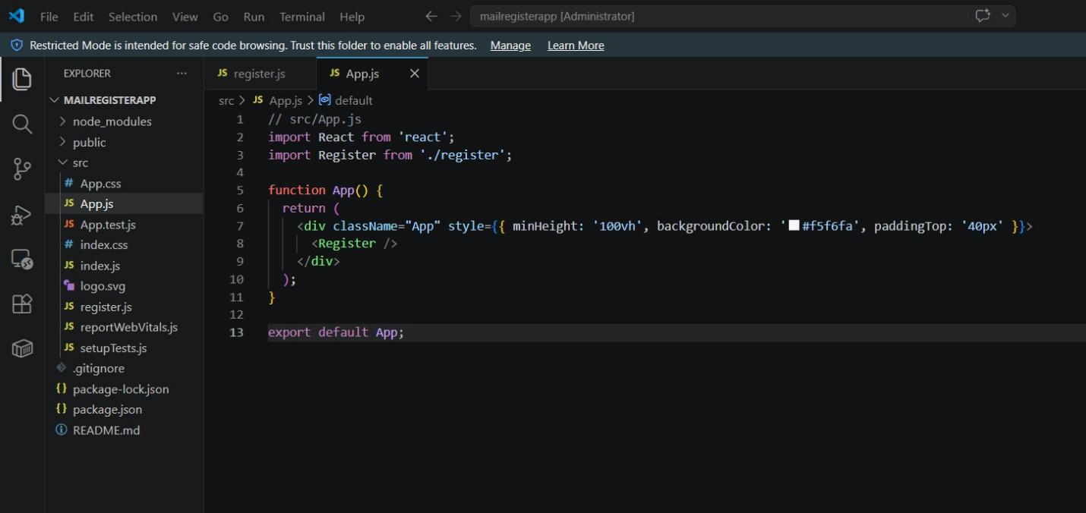
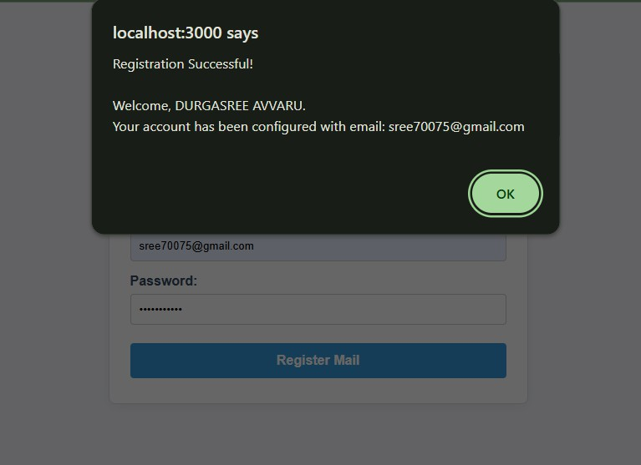

ReactJS HOL – 15
Create a React Application “fetchuserapp” which will retrieve the user details from
https://api.randomuser.me/ and display the title, firstname and image of a user.

Create a component named “Getuser” and in the asynchronous method “ComponentDidMount ()” invoke the URL using fetch method and the response can be displayed in the render method of the component.
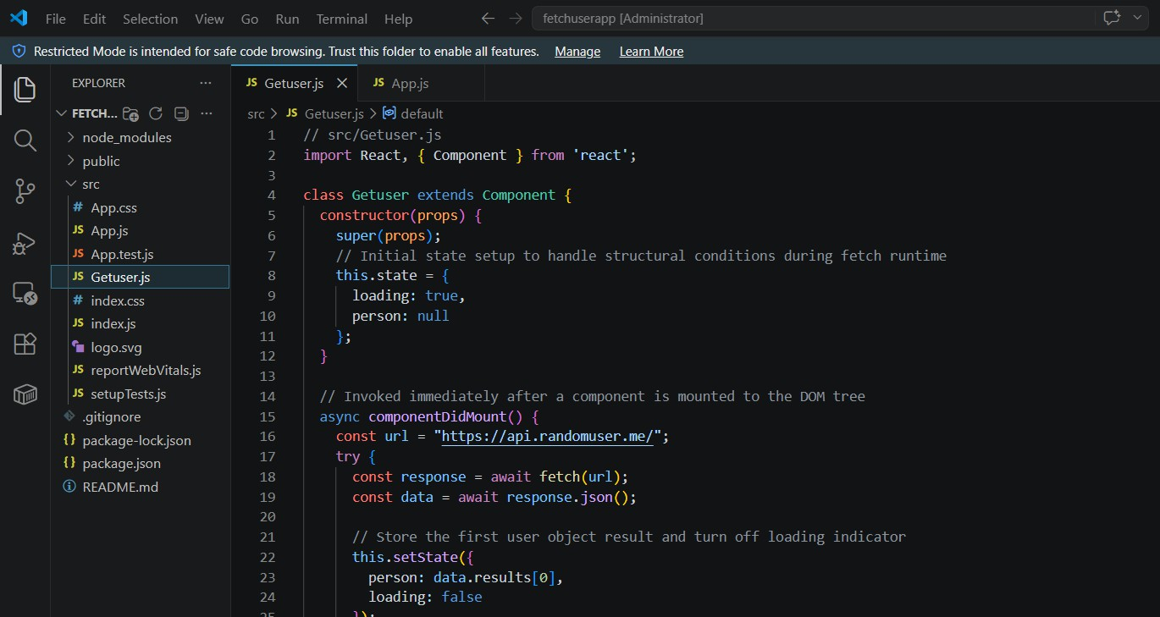
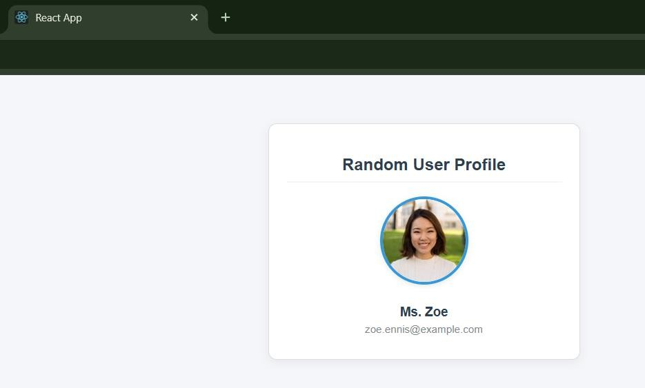

ReactJS HOL – 16

As an intern at OpenAI you are assigned the task of creating and testing a React application which will fetch and display a list of repository names for a given user.
Create a new React application using create-react-app tool and name it as “gitclientapp”.
